**What are all dependency used to implement Spring JDBC project?**

* Spring JDBC
* Spring Core
* Spring Context
* Mysql connector

**What is Spring JDBC?**

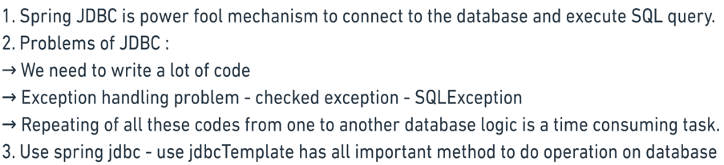

**How to configure JDBC file using bean annotation & xml?**

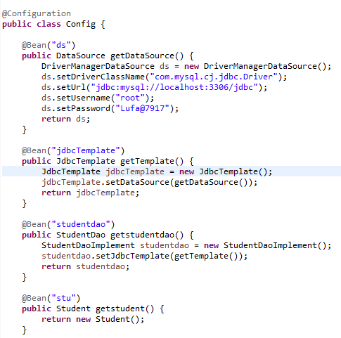 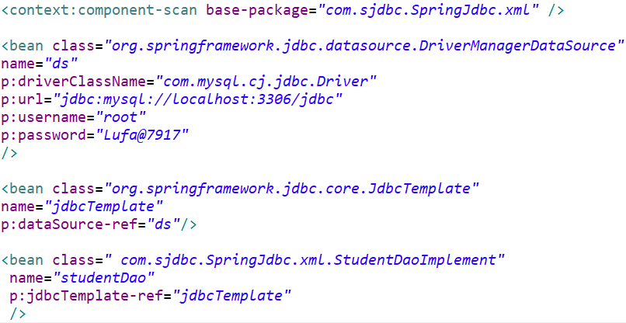

**What is architecture need to follow in Spring JDBC?**

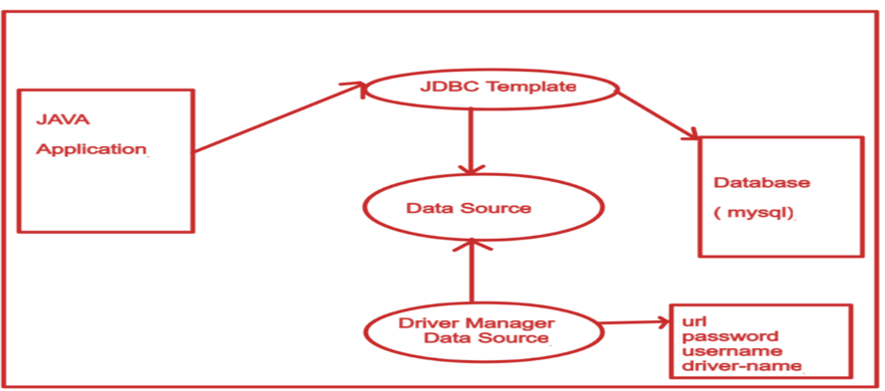

**How to get single object & all objects from database?**

* **Use Row mapper interface:**



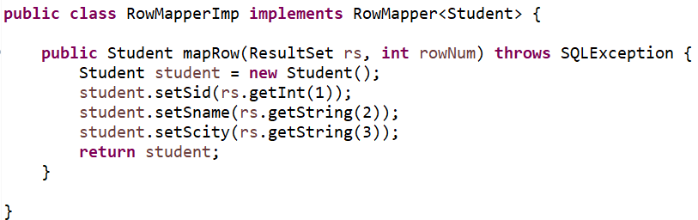

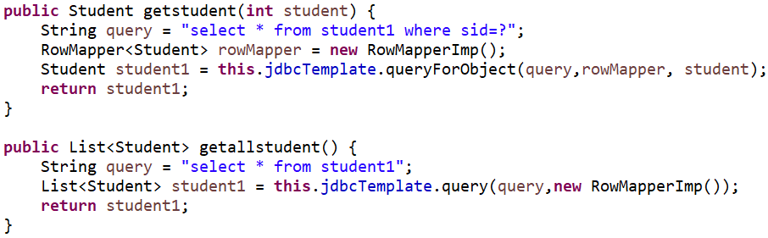

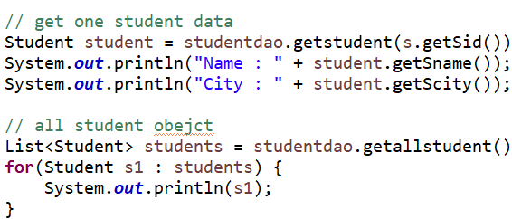

**How to do insert, update, delete in Spring JDBC?**

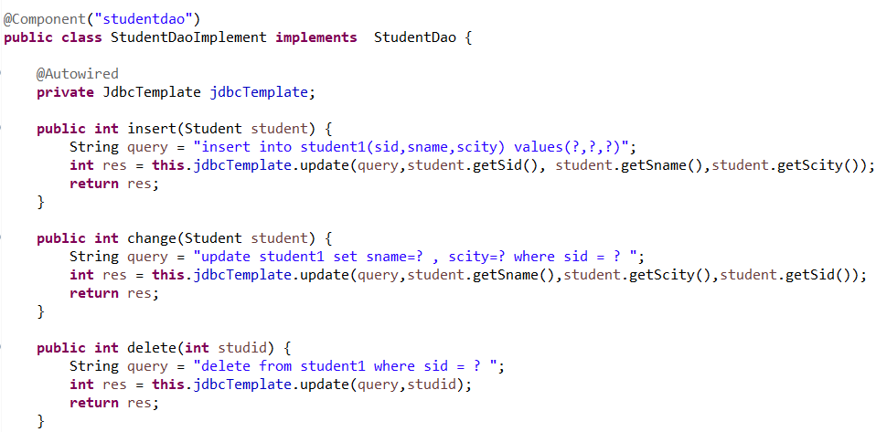

**What are all dependency used to implement Spring hibernate project?**

* Spring core
* Spring context
* Hibernate core
* Spring orm
* Mysql connector

**Why we need Spring hibernate?**

It is used when need to implement application be ORM tool

It has many advantages like automatic creating query, database independent, light weight etc

**What is pattern we need follow to implement Spring hibernate?**

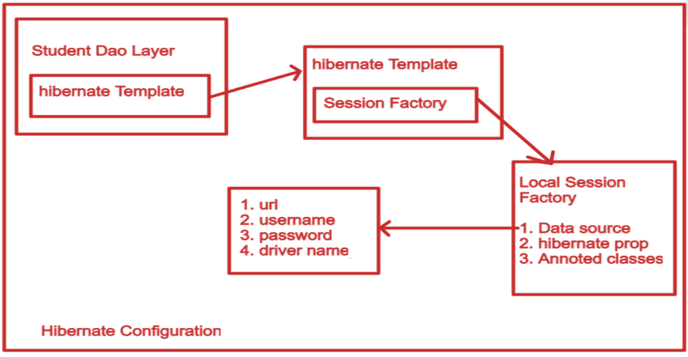

**How to configure hibernate file using bean annotation & xml?**

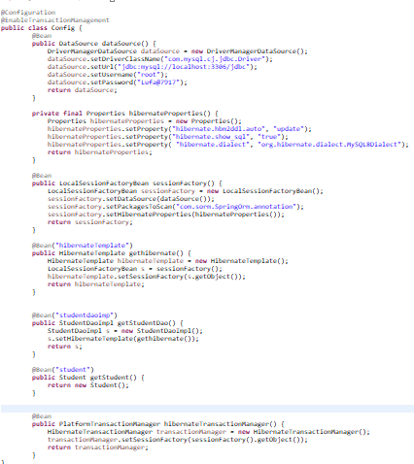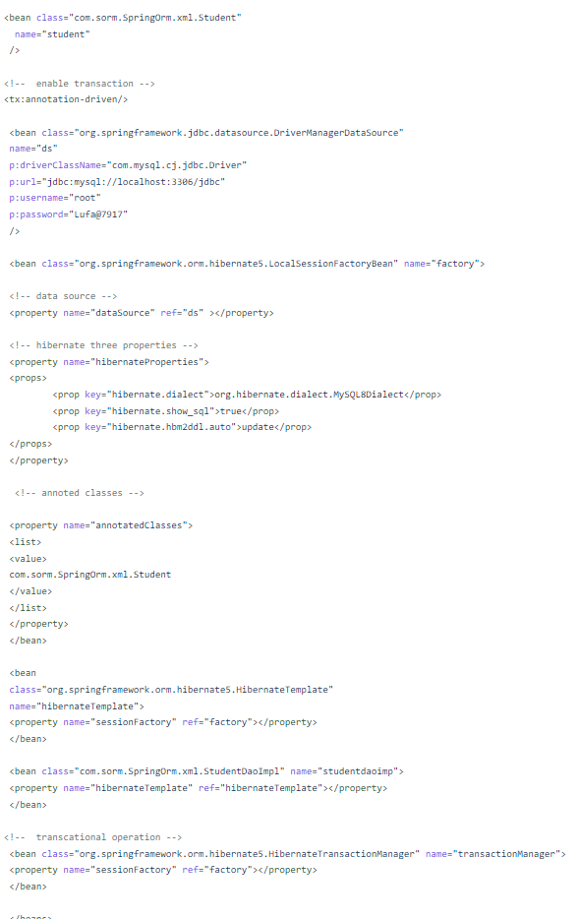

**How to get single object & all objects from database in hibernate?**

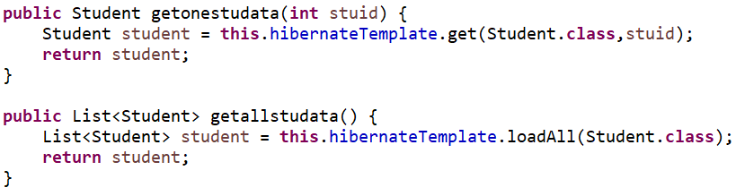

**How to do insert, update, delete in Spring ORM?**

